Additional Science – Physics PU2.2 Stretching an Elastic Band
Physics Glossary.

- Elastic – a material that is able to return its shape after it has been stretched

- Elastic limit – the point at which an elastic material will no longer return to its original length after being stretched

- Newtons (N) – the unit of force

- Extension – the increases in the distance when an elastic object is stretched

- Hooke’s Law - The extension of an elastic object is directly proportional to the force applied to it until the elastic limit

- 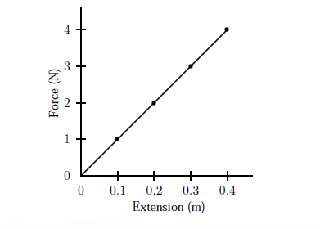Directly Proportional – As one increases, the other increases by the same percentage

- Metres (m) – the unit of distance

- Elastic Potential Energy – energy stored in an object because it is stretched, compressed or deformed, and when released the object returns to its original shape.

